EXERCISE 1

CODE:

<!DOCTYPE html>  
<html lang="en">  
<head>  
    <meta charset="UTF-8">  
    <title>My First HTML Page</title>  
</head>  
<body>  
    <h1>Nishmitha</h1>  
    <p>I enjoy travelling and watching movies. I also have the collection of coins from different countries</p>  
    <hr>  
    <br>  
</body>  
</html>

**OUTPUT:**

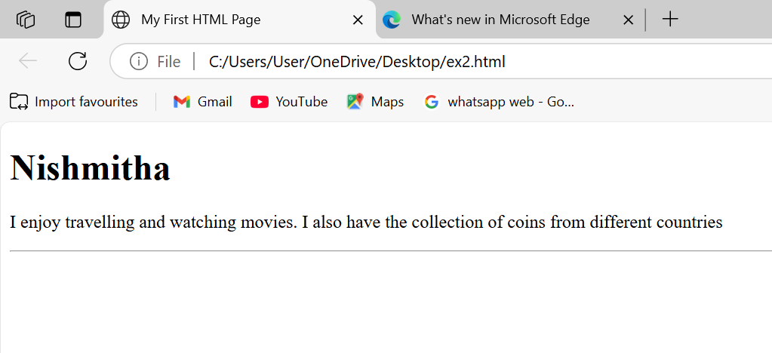

EXERCISE 2

CODE:

<!DOCTYPE html>  
<html lang="en">  
<head>  
    <meta charset="UTF-8">  
    <title>Lists and Links</title>  
</head>  
<body>  
    <h1>My Favorite Movies</h1>  
    <ul>  
        <li>HIT</li>  
        <li>FINAL DESTINATION</li>  
        <li>MILANA</li>  
        <li>GOD FATHER</li>  
    </ul>  
  
    <h1>Top 3 Movies</h1>  
    <ol>  
        <li>Inception</li>  
        <li>Interstellar</li>  
        <li>The Dark Knight</li>  
    </ol>  
  
    <h1>My Favorite Website</h1>  
    <p>  
        Visit <a href="[https://www.pinterest.com](https://www.pinterest.com/)" target="_blank">this website</a> to explore more!  
    </p>  
</body>  
</html>

**OUTPUT:**

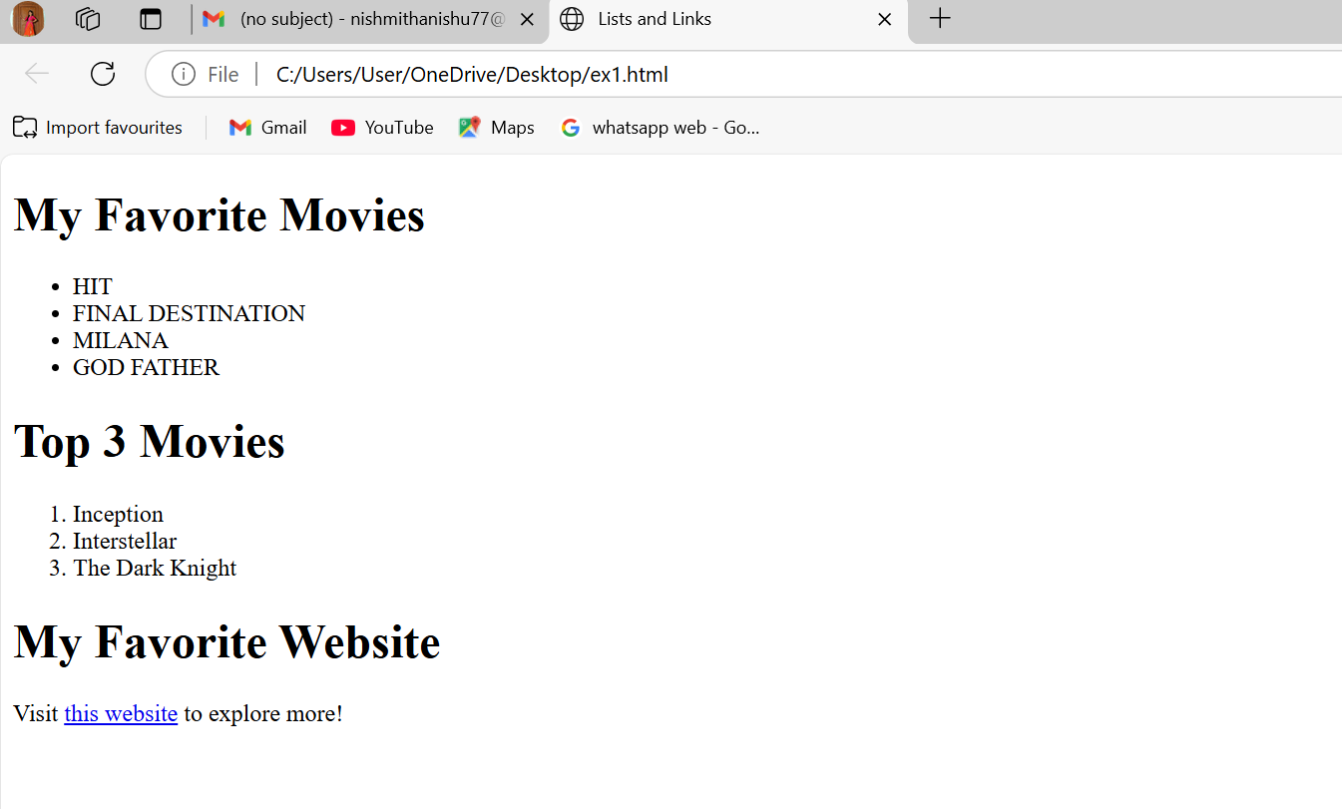

EXERCISE 3

CODE:

<!DOCTYPE html>

<html>

<head>

<title>Exercise 3: Images and Tables</title>

</head>

<body>

<h2>Sample Image</h2>

<img src="https://via.placeholder.com/150" alt="Placeholder Image">

<h2>Student Information Table</h2>

<table border="1" cellpadding="8" cellspacing="0">

<tr>

<th>Student Name</th>

<th>Age</th>

<th>Favorite Subject</th>

</tr>

<tr>

<td>Nishmitha</td>

<td>23</td>

<td>Mathematics</td>

</tr>

<tr>

<td>Deeksha</td>

<td>21</td>

<td>Physics</td>

</tr>

<tr>

<td>Ananya</td>

<td>19</td>

<td>Computer Science</td>

</tr>

</table>

</body>

</html>

**OUTPUT:**

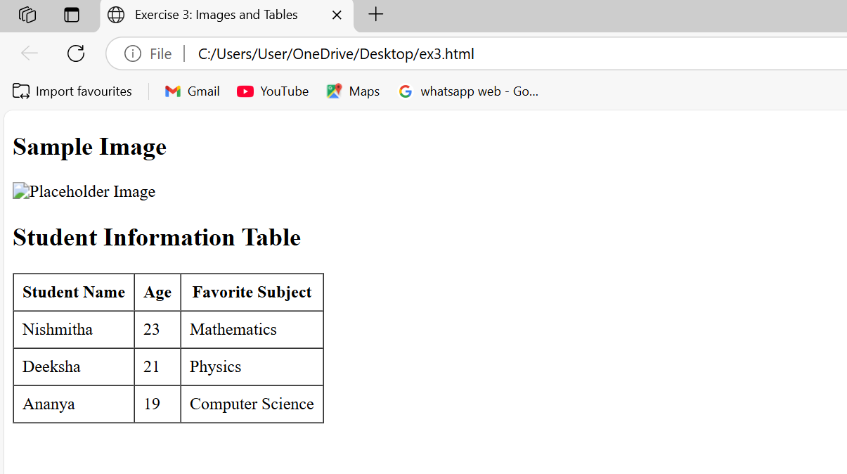

EXERCISE 4

CODE:

<!DOCTYPE html>

<html>

<head>

<title>Exercise 4: Introduction to CSS</title>

<style>

h1 {

background-color: lightblue;

color: darkblue;

font-size: 30px;

}

p {

font-family: Arial, sans-serif;

text-align: justify;

}

</style>

</head>

<body>

<h1>Welcome to CSS Styling</h1>

<p>

CSS (Cascading Style Sheets) allows you to apply styles to HTML elements.

You can control layout, colors, fonts, and more. This paragraph is styled

using Arial font and justified text alignment.

</p>

</body>

</html>

**OUTPUT:**

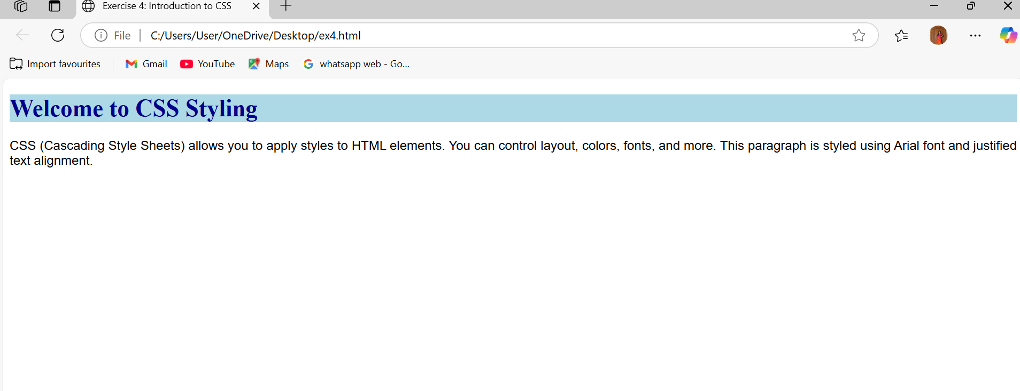

EXERCISE 5

CODE:

<!DOCTYPE html>

<html>

<head>

<title>Exercise 5: CSS Classes and IDs</title>

<style>

#intro {

border: 2px solid black;

padding: 10px;

}

.highlight {

background-color: red;

}

</style>

</head>

<body>

<div id="intro">

<p>This is the introduction section styled using an ID with a border and padding.</p>

</div>

<div class="highlight">

<p>This is a highlighted section styled using a class with a red background.</p>

</div>

</body>

</html>

**OUTPUT:**

